

Jamhuri ya Muungano wa Tanzania
Wizara ya Kilimo
Sehemu ya Masoko ya Mazao ya Kilimo

Taarifa ya Wiki ya Mwenendo wa Bei za Mazao 21 - 25 Oktoba 2024
Jedwali 1: Wastani wa bei za jumla Kitaifa (TZS/ kil

Ujumbe Mkuu

Mazao makuu ya chakula
Bei za jumla
:
zimebadilika kwa viwango tofauti ikilinganishwa na viwango vya wastani wa bei za wiki iliyopita. Bei

ya

uwele

imepungua

kwa
asilimia 5.9

wakati
bei z
a

mahindi, mchele,

maharage, mtama
,

ulezi
na viazi mviringo
hazijabadilika.

Kakao:

Hadi kufikia
tarehe
21

Okto
ba, 2024 kakao iliyouzwa kwa msimu wa mauzo 2024/2025 ni kilo
3,617,250.0

zenye

thamani ya Shilingi

Bilioni
71
.

Kahawa
:
Hadi kufikia
tarehe 18

Okto
ba, 2024 kahawa iliyouzwa kwa msimu wa mauzo 2024/2025 ni kilo

32,214,535

zenye
thamani ya Dola za

Marekani Milioni
1
36
.

Wiki iliyopita | 14 - 18 Oktoba, 2024 |  | Wiki hii | 21- 25 Oktoba, 2024
 | Wiki | Mahindi | Mchele | Maharage | Mtama | Uwele | Ulezi | Viazi mviringo
Wastani wa Nchi | Wiki hii | 600 | 2,000 | 2,700 | 1,500 | 1,600 | 1,700 | 1,100
Wastani wa Nchi | Wiki iliyopita | 600 | 2,000 | 2,700 | 1,500 | 1,700 | 1,700 | 1,100
Wastani wa Nchi | Badiliko | ►0.0% | ►0.0% | ►0.0% | ►0.0% | ▼5.9% | ►0.0% | ►0.0%

Jedwali 2: Wastani wa bei za jumla kwa Mikoa (TZS/ kilo)
Mkoa Wiki Mahindi Mchele Maharage Mtama Uwele Ulezi Viazi mviringo
Dodoma | Wiki hii | 600 | 1,900 | 2,800 | 600 | 500 | 1,800 | 700
 | Wiki iliyopita | 900 | 1,900 | 2,800 | 500 | 500 | 1,800 | 700
 | Badiliko | ▼33.3% | ►0.0% | ►0.0% | ▲20.0% | ►0.0% | ►0.0% | ►0.0%
Arusha | Wiki hii | 600 | 3,300 | 2,500 | 1,000 | 900 | 1,500 | 900
 | Wiki iliyopita | 600 | 3,300 | 2,600 | 1,000 | 800 | 1,500 | 1,000
 | Badiliko | ►0.0% | ►0.0% | ▼3.8% | ►0.0% | ▲12.5% | ►0.0% | ▼10.0%
Dar es Salaam | Wiki hii | 800 | 2,300 | 3,100 | 1,100 | 1,000 | 1,800 | 800
 | Wiki iliyopita | 600 | 2,200 | 3,000 | 1,400 | 1,300 | 1,900 | 1,000
 | Badiliko | ▲33.3% | ▲4.5% | ▲3.3% | ▼21.4% | ▼23.1% | ▼5.3% | ▼20.0%
Lindi | Wiki hii | 700 | 2,300 | 2,700 | 2,400 | 2,800 | 1,900 | 900
 | Wiki iliyopita | 800 | 2,400 | 2,700 | 2,000 | 2,900 | 2,400 | 900
 | Badiliko | ▼12.5% | ▼4.2% | ►0.0% | ▲20.0% | ▼3.4% | ▼20.8% | ►0.0%
Morogoro | Wiki hii | 700 | 2,100 | 2,700 | 1,300 | 1,300 | 1,400 | 800
 | Wiki iliyopita | 600 | 2,100 | 2,700 | 1,300 | 1,300 | 1,500 | 800
 | Badiliko | ▲16.7% | ►0.0% | ►0.0% | ►0.0% | ►0.0% | ▼6.7% | ►0.0%
Tanga | Wiki hii | 900 | 1,800 | 2,600 | 1,100 | 2,000 | 2,000 | 1,500
Mtwara | Wiki hii | 600 | 2,300 | 2,700 | 2,000 | 4,000 | 2,000 | 1,000
 | Wiki iliyopita | 600 | 2,300 | 2,700 | 2,000 | 4,000 | 2,000 | 1,000
 | Badiliko | ►0.0% | ►0.0% | ►0.0% | ►0.0% | ►0.0% | ►0.0% | ►0.0%
Iringa | Wiki hii | 500 | 2,000 | 2,500 | 1,100 | 1,400 | 1,800 | 800
 | Wiki iliyopita | 500 | 2,000 | 2,500 | 1,100 | 1,400 | 1,700 | 800
 | Badiliko | ►0.0% | ►0.0% | ►0.0% | ►0.0% | ►0.0% | ▲5.9% | ►0.0%
Ruvuma | Wiki hii | 500 | 2,400 | - | - | - | 1,100 | 800
 | Wiki iliyopita | 700 | 2,300 | - | - | - | 700 | 900
 | Badiliko | ▼28.6% | ▲4.3% |  |  |  | ▲57.1% | ▼11.1%
Tabora | Wiki hii | 600 | 1,400 | 2,700 | 1,700 | 1,900 | 1,900 | 900
 | Wiki iliyopita | 600 | 1,400 | 2,600 | 1,700 | 1,900 | 1,800 | 900
 | Badiliko | ►0.0% | ►0.0% | ▲3.8% | ►0.0% | ►0.0% | ▲5.6% | ►0.0%
Rukwa | Wiki hii | 600 | 1,900 | 2,700 | - | - | 1,300 | 900
 | Wiki iliyopita | 600 | 2,000 | 2,600 | - | - | 1,200 | 900
 | Badiliko | ►0.0% | ▼5.0% | ▲3.8% |  |  | ▲8.3% | ►0.0%
Kigoma | Wiki hii | 700 | 1,700 | 2,000 | 1,400 | 1,500 | 2,000 | 1,000
 | Wiki iliyopita | 700 | 1,700 | 2,200 | 1,800 | 1,900 | 2,000 | 900
 | Badiliko | ►0.0% | ►0.0% | ▼9.1% | ▼22.2% | ▼21.1% | ►0.0% | ▲11.1%

Mkoa Wiki Mahindi Mchele Maharage Mtama Uwele Ulezi Viazi mviringo
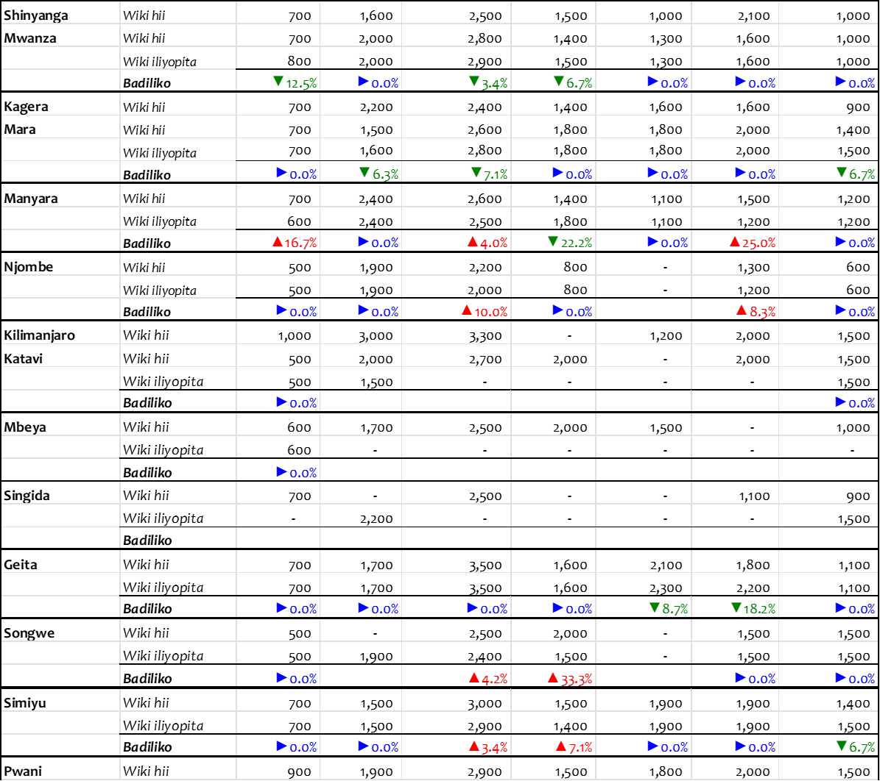
Chanzo: Wizara ya Kilimo, 2024

Zingatia:
- Bei hizi ni wastani wa bei za jumla katika soko kuu la mkoa husika.
- Alama (▲▼►) zinaelezea mabadiliko ya bei: (▲) bei imeongezeka; (▼) bei imepungua; (►) hakuna mabadiliko ya bei. ✓ (-): bei haikupatikana.

Jedwali 3: Wastani wa Bei (TZS) za mazao ya Horticulture katika masoko mbalimbali kwa wiki ya tarehe 04 Oktoba -09 Oktoba, 2024
 | WASTANI WA BEI ZA MAZAO YA HORTICULTURE KATIKA MASOKO MBALIMBALI(Tsh/Kg)
NA. | Mkoa | Wiki | Vitunguu | Nyanya | Karoti | Viazi mviringo | Kitunguu swaumu | Pilipili hoho | Tikiti maji
1 | Dar es Salaam | Wiki hii | 3,200 | 900 | 1,200 | 2,800 | 12,000 | 3,500 | 750
1 | Dar es Salaam | Wiki iliyopita | 3,200 | 700 | 1200 | 4,000 | 10,000 | 2,300 | 750
 |  | %Badiliko | 0% | 29% | 0% | -30% | 20% | 52% | 0%
2 | Arusha | Wiki hii | 3,400 | 400 | 2,800 | 3,200 | 9,000 | 3,000 | 670
2 | Arusha | Wiki iliyopita | 3,600 | 600 | 1700 | 3,200 | 10,000 | 2,800 | 850
 |  | %Badiliko | -6% | -33% | 65% | 0% | -10% | 7% | -21%
3 | Dodoma | Wiki hii | 2,800 | 400 | 1,400 | 2,700 | 12,000 | 2,900 | 750
3 | Dodoma | Wiki iliyopita | 3,000 | 500 | 1,400 | 2,700 | 11,000 | 2,300 | 650
 |  | %Badiliko | -7% | -20% | 0% | 0% | 9% | 26% | 15%
4 | Mwanza | Wiki hii | 3,500 | 600 | 2,100 | 1,200 | 8,000 | 2,100 | 750
4 | Mwanza | Wiki iliyopita | 2,400 | 800 | 1,100 | 800 | 5,000 | 2,100 | 750
 |  | %Badiliko | 46% | -25% | 91% | 50% | 60% | 0% | 0%
5 | Kilimanjaro | Wiki hii | 2,800 | 700 | 1,300 | 2,300 | 8,000 | 3,200 | 800
5 | Kilimanjaro | Wiki iliyopita | 3,900 | 700 | 1,300 | 1,600 | 8,000 | 2,800 | 800
 |  | %Badiliko | -28% | 0% | 0% | 44% | 0% | 14% | 0%
6 | Manyara | Wiki hii | 2000 | 400 | 1,800 | 2,000 | 6,000 | 2,700 | 600
6 | Manyara | Wiki iliyopita | 1,700 | 400 | 1,800 | 2,500 | 5,000 | 2,100 | 600
 |  | %Badiliko | 18% | 0% | 0% | -20% | 20% | 29% | 0%
Chanzo: TAHA, 2024

Jedwali 4: Mauzo ya kakao kwa msimu wa 2024/2025 hadi kufikia tarehe 21 Oktoba, 2024
 | Halmashauri |  | Kiasi kilichouzwa (Kilo) | Wastani wa Bei (Shilingi/Kilo) | Jumla (Shilingi) ch
Kyela (Kilo) | Busokelo (Kilo) | Rungwe (Kilo) | Kiasi kilichouzwa (Kilo) | Wastani wa Bei (Shilingi/Kilo) | Jumla (Shilingi) ch
2,416,960.0 | 800,240.0 | 389,060.0 | 3,617,250.0 | 20,682.36 | 71,977,328,220.00
Chanzo: Tume ya Maendeleo ya Ushirika Tanzania, 2024

Jedwali 5: Mauzo ya kahawa kwa msimu wa mwaka 2024/2025 hadi kufikia tarehe 18 Oktoba, 2024
Aina ya Kahawa | Mnada |  | Soko la moja kwa moja |  | Viwanda vya ndani |  |  | Jumla
Aina ya Kahawa | Kilo | Dola za Marekani | Kilo | Dola za Marekani | Kilo | Dola za Marekani | Kilo | Dola za Marekani
Arabika Laini | 4,345,359 | 18,900,006.66 | 10,754,902 | 50,764,352.63 | 4,883 | 23,859.36 | 15,105,144 | 69,688,218.65
Arabika Ngumu |  |  | 304,440 | 1,173,204.18 |  |  | 304,440 | 1,173,204.18
Robusta |  |  | 16,804,951 | 66,132,169.54 |  |  | 16,804,951 | 66,132,169.54
Jumla | 4,345,359 | 18,900,006.66 | 27,864,293 | 118,069,726.35 | 4,883 | 23,859.36 | 32,214,535 | 136,993,592.37
Chanzo: Bodi ya Kahawa Tanzania, 2024

Jedwali 6: Miezi sahihi ya kupanda na kuvuna ili kupata bei nzuri
Zao | Wakati unaofaa kuvuna | Wakati usiofaa kuvuna | Wakati unaofaa kupanda
Vitunguu | Feb- Julai | Julai- Nov | Sept- Des
Nyanya | Jan- Mei | Des – Juni | Sept- Des
Hoho kijani | Feb- Aprili | Juni - Jan | Okt- Nov
Karoti | Okt- Machi | Sep - Apr | Julai- Okt
Matango | Feb- Mei | Mei - Jan | Des- Jan
Viazi mviringo | Machi- Juni | Julai - Jan | Des- Feb
Tikiti maji | Machi- Aprili, Oktoba - Desemba | Mei- Sep, Des- Feb | Jan- Feb, Ago- Sept
Hoho za rangi | Jun- Nov | Mei – Des | Feb- Machi
Tangawizi | Aprili- Julai | Machi – Aug | Des- Feb
Chanzo: TAHA, 2023

Habari Muhimu
✓ Wizara ya Kilimo imeanzisha jukwaa la soko la mtandaoni (M-Kilimo) ili kuwezesha upatikanaji wa huduma za masoko kwa wakulima na wafanyabiashara kupitia simu zao za mkononi, jinsi ya kupata huduma ;- ❖ USSD: Piga * 152*00# chagua Na. 7 kisha Na. 2 halafu fuata maelekezo
❖ Tovuti: fungua exts.kilimo.go.tz kisha chagua huduma
Taarifa ya wiki ya mwenendo wa bei ya mazao ya kilimo inapatikana katika tovuti ya www.kilimo.go.tz
Kwa maelezo zaidi wasiliana na: Sehemu ya Masoko ya Mazao, Wizara ya Kilimo, S.L.P 2182, DODOMA. Barua pepe: masoko@kilimo.go.tz

